Nama : Firly Nurlya R
NIM : 4510210032
Praktikum sesi 7 - Pemrograman 4

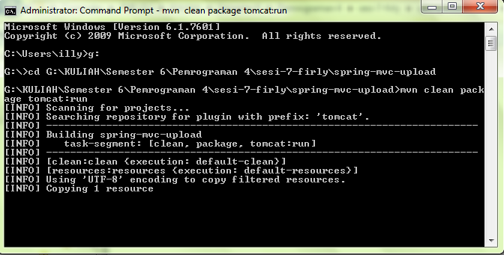
Upload.java
package com.belajar.web;
/**
* Hello world!
*
*/
public class Upload
{
private String fileName;
private Long ukuran;

public void setFileName(String fileName){
this.fileName = fileName;
}

public String getFileName(){
return fileName;
}

public void setUkuran(Long ukuran){
this.ukuran = ukuran;
}
public Long getUkuran(){
return ukuran;
}
}

UploadController.java
package com.belajar.web;

import java.io.File;
import java.util.ArrayList;
import java.util.List;
import org.springframework.stereotype.Controller;
import org.springframework.ui.ModelMap;
import org.springframework.web.bind.annotation.RequestMapping;
import org.springframework.web.bind.annotation.RequestMethod;
import org.springframework.web.bind.annotation.RequestParam;
import org.springframework.web.multipart.MultipartFile;

/**
*
* @author didik wahyudi
*/
@Controller
public class UploadController {

@RequestMapping(value = "/foto/uploadFoto", method = RequestMethod.GET)
public void UploadFoto() {
System.out.print("upload foto");
}

@RequestMapping(value = "/foto/uploadFoto", method = RequestMethod.POST)
public ModelMap ProsesUploadFoto(@RequestParam("photofile") MultipartFile hasilUpload) throws Exception {
String fileName = hasilUpload.getOriginalFilename();
File file = new File("src/main/webapp/WEB-INF/templates/foto upload/"+fileName);
hasilUpload.transferTo(file);
ModelMap mm = new ModelMap();
String pesan = "sudah di upload";
mm.addAttribute("pesan", pesan);
return mm;

//System.out.print("proses upload foto");
}
@RequestMapping("/foto/daftarFoto")
public ModelMap daftarFoto() {
List<Upload> f = new ArrayList<Upload>();
String dir = "src/main/webapp/WEB-INF/templates/foto upload/";
File fileFoto = new File(dir);
File[] daftar = fileFoto.listFiles();
for(File file : daftar){
if(file.isFile()){
Upload u = new Upload();
u.setFileName(file.getName());
u.setUkuran(file.length()/1024);
f.add(u);
}
}

ModelMap mm = new ModelMap();
mm.addAttribute("daftarFoto", f);
return mm;
}
}

